INTRODUCTION TO CLOUD AND AWS
Agenda
- Introduction to Cloud Computing
- Cloud Computing Models
- Types of Cloud Environments
  - Public Cloud
  - Private Cloud
  - Hybrid Cloud
- Introduction to AWS
- Common Use Cases
- Real-World Applications of AWS
- Overview of AWS Core Services
- AWS Pricing Models
- AWS Free Tier Account Setup
Introduction to Cloud Computing:
Cloud Computing is the delivery of various computing services over the internet, enabling businesses and individuals to access and utilize resources without the need for physical infrastructure. These services are provided by cloud service providers and are billed on a pay-as-you-go basis, offering flexibility, scalability, and cost efficiency.

Key Features of Cloud Computing:
- On-Demand Self-Service: Users can provision resources automatically as needed, without requiring human interaction with the service provider.
- Broad Network Access: Resources are available over the internet and can be accessed from anywhere using devices like laptops, smartphones, or tablets.
- Resource Pooling: Multiple users share a pool of resources dynamically assigned and reassigned based on demand.
- Scalability and Elasticity: Resources can scale up or down automatically to meet workload demands.
- Measured Service: Usage is monitored, controlled, and billed based on actual consumption, ensuring cost-efficiency.
Popular providers include Amazon Web Services (AWS), Microsoft Azure, and Google Cloud Platform (GCP).
Characteristics of Cloud Computing:
- On-Demand Self-Service:
  - Users can access resources as needed without human interaction from the provider.
- Pay-As-You-Go Pricing:
  - Customers only pay for the resources they use, reducing upfront capital expenditure.
- Scalability:
  - Automatic scaling of resources to meet fluctuating demands.
  - Includes vertical scaling (adding more power to an existing machine) and horizontal scaling (adding more machines).
- Broad Network Access:
  - Resources are accessible over the internet, enabling use from multiple devices.
- Resource Pooling:
  - Providers use a multi-tenant model where resources are dynamically assigned based on demand.
- Rapid Elasticity:
  - Resources can be quickly scaled up or down, often appearing limitless to users.
- Measured Service:
  - Usage is monitored, controlled, and reported for transparency.
Cloud Computing Models:
1. IaaS (Infrastructure as a Service)
Infrastructure as a Service (IaaS) is a cloud computing model that provides virtualized computing resources over the internet. It allows users to access and manage essential infrastructure components without the need to invest in and maintain physical hardware.
Key Features of IaaS:
- Virtualized Hardware: Provides virtual machines, storage, and networking resources.
- Scalability: Resources can be scaled up or down based on demand.
- Pay-as-You-Go Pricing: Users pay only for the resources they consume.
- Full Control: Users manage their applications, operating systems, and middleware, giving them significant flexibility.
User and Provider Responsibilities:
- Users Manage:
  - Operating Systems
  - Applications
  - Middleware (e.g., databases, runtime environments)
- Providers Manage:
  - Virtualization (creating and managing virtual machines)
  - Networking (firewalls, load balancers, etc.)
  - Storage (data backups, disks, etc.)
  - Physical Servers (hardware, power, and cooling)
Examples of IaaS:
- AWS EC2: Amazon Elastic Compute Cloud offers scalable virtual servers in the cloud.
- Google Compute Engine: Provides virtual machines hosted on Google's infrastructure.
- Microsoft Azure Virtual Machines: Offers a wide range of VM options for various use cases.
Use Cases of IaaS:
- Website Hosting: Deploying websites with dynamic content or high traffic.
- Data Analysis: Processing large datasets with high-performance computing resources.
- Running Virtual Machines: Hosting and managing virtualized environments for development, testing, and production.
2. PaaS (Platform as a Service)
Platform as a Service (PaaS) is a cloud computing model that provides a platform and environment for developers to build, deploy, and manage applications. PaaS eliminates the complexities of managing the underlying infrastructure, allowing developers to focus on application development and innovation.
Key Features of PaaS:
- Development Frameworks: Provides tools and frameworks for rapid application development.
- Integrated Environment: Includes services like databases, runtime environments, and APIs.
- Simplified Deployment: Allows developers to deploy applications without worrying about server configurations.
User and Provider Responsibilities:
- Providers Manage:
  - Infrastructure (servers, storage, networking)
  - Operating System (updates, patches)
  - Middleware (runtime environments, databases)
- Developers Focus On:
  - Application development (coding, testing)
  - Deployment and scaling of applications
Examples of PaaS:
- Google App Engine: A fully managed platform for building scalable web and mobile applications.
- Microsoft Azure App Service: Supports multiple programming languages and frameworks for app deployment.
- AWS Elastic Beanstalk: Simplifies application deployment using pre-configured environments.
Use Cases of PaaS:
- Application Development: Creating custom applications quickly without managing infrastructure.
- Testing and Deployment: Automating testing and deployment pipelines for continuous delivery.
- Integration Services: Building applications that integrate seamlessly with other services and APIs.
3.SaaS (Software as a Service)
Software as a Service (SaaS) is a cloud computing model that delivers software applications over the internet on a subscription basis. SaaS solutions are fully managed by the provider, enabling users to access and use the software without worrying about infrastructure or maintenance.
Key Features of SaaS:
- Accessible Anywhere: Users can access the software through a web browser or app on any device.
- Subscription-Based: Typically offered as a monthly or annual subscription.
- No Maintenance: Providers handle software updates, bug fixes, and infrastructure management.
User and Provider Responsibilities:
- Providers Handle:
  - Infrastructure (servers, storage, networking)
  - Operating System and Middleware
  - Application (updates, security, and features)
- Users: Simply access and use the software through an intuitive interface.
Examples of SaaS:
- Gmail: Provides email services accessible from any device.
- Salesforce: A customer relationship management (CRM) platform with robust business tools.
- Microsoft Office 365: Offers productivity tools like Word, Excel, and Teams in the cloud.
Use Cases of SaaS:
- Collaboration: Teams can collaborate in real-time using tools like Google Workspace or Microsoft Teams.
- Communication: Services like Zoom and Slack enable seamless communication across devices.
- Business Applications: CRM, ERP, and analytics tools for managing business operations effectively.
Types of Cloud Environments:
1. Public Cloud
A Public Cloud is a cloud environment operated by third-party providers, where computing resources such as servers, storage, and networking are shared among multiple users (multi-tenant). These resources are accessible over the internet, making them widely available and easy to scale.
Advantages:
- Cost-Effective: Users pay only for the resources they use, eliminating the need for upfront investments in infrastructure.
- Scalable: Resources can be increased or decreased as needed with minimal effort, catering to variable workloads.
- No Maintenance: The provider handles maintenance, updates, and hardware management, reducing operational burdens for users.
Examples:
- Amazon Web Services (AWS)
- Google Cloud Platform (GCP)
- Microsoft Azure
Use Case:
Public clouds are ideal for startups and small to medium-sized businesses that have variable workloads, as they provide affordable and scalable solutions without requiring extensive technical expertise.
2. Private Cloud
A Private Cloud is a cloud environment that is dedicated to a single organization. It can be hosted on the organization’s on-premises infrastructure or managed by a third-party provider. This model offers exclusive access to resources, giving organizations greater control over their data and systems.
Advantages:
- Enhanced Security: Provides robust security measures, making it suitable for industries with strict compliance requirements.
- Customizable: Organizations can tailor the infrastructure to meet specific business needs and performance requirements.
- Control: Greater control over the data, resources, and applications as they are not shared with others.
Examples:
- VMware Private Cloud
- IBM Private Cloud
Use Case:
Private clouds are commonly used by industries like finance, healthcare, and government, where data privacy, security, and regulatory compliance are critical.
3. Hybrid Cloud:
A Hybrid Cloud combines the features of both public and private cloud environments, allowing data and applications to be shared between them. This model offers businesses the flexibility to keep sensitive workloads on private clouds while utilizing public clouds for scalable, non-sensitive tasks.
Advantages:
- Flexibility: Enables organizations to move workloads seamlessly between private and public environments based on current requirements.
- Cost-Effectiveness: Balances the cost by utilizing the public cloud for scalable workloads while retaining sensitive data in the private cloud.
- Enhanced Performance: Optimizes resource utilization by dividing workloads between environments as needed.
Examples:
- AWS Outposts
- Microsoft Azure Stack
Use Case:
Hybrid clouds are well-suited for businesses that require both scalability and data security, such as enterprises managing customer-facing applications on the public cloud while maintaining sensitive records in a private cloud.
Introduction to AWS:
AWS, or Amazon Web Services, is a comprehensive and widely adopted cloud computing platform provided by Amazon. Launched in 2006, AWS offers a broad set of on-demand services such as computing power, storage, databases, networking, machine learning, analytics, and more. It empowers businesses of all sizes to build and scale applications efficiently without the need for physical infrastructure.

Overview of Amazon Web Services:
AWS is considered the pioneer and market leader in the cloud computing space, with millions of customers, including startups, enterprises, and government agencies.
Key Features of AWS:
- Pay-As-You-Go Model: Users only pay for what they use, avoiding upfront costs.
- On-Demand Resources: Instantly scale resources up or down based on business needs.
- Broad Service Portfolio: Offers over 200 fully featured services, ranging from storage (S3) to advanced machine learning tools (SageMaker).
- Global Reach: AWS operates in multiple geographic regions worldwide, ensuring low-latency access and high availability.
- Reliability and Security: AWS provides strong compliance standards, end-to-end encryption, and robust disaster recovery options.
AWS as the Leading Cloud Service Provider:
AWS holds the largest share in the cloud market, consistently ranking as the top cloud service provider globally.
Why AWS Dominates:
- Innovation: AWS continuously innovates by introducing new services and features to meet evolving customer needs.
- Economies of Scale: AWS operates at a massive scale, enabling cost advantages that are passed on to customers.
- Diverse Ecosystem: With a vast array of services, AWS supports various use cases, from startups launching apps to enterprises managing global IT infrastructures.
- Customer Trust: Its robust security, compliance certifications, and proven reliability have earned the trust of organizations worldwide.
Key Benefits of Using AWS:
- Scalability:
  - AWS allows businesses to scale their resources seamlessly. Whether it's handling increased website traffic or processing large datasets, AWS offers elastic scalability with services like EC2 Auto Scaling and AWS Lambda.
- Flexibility:
  - AWS supports multiple programming languages, frameworks, and operating systems. Businesses can deploy solutions that align with their specific needs and easily integrate AWS services into their existing infrastructure.
- Security:
  - AWS provides a secure cloud environment with features like encryption, identity and access management (IAM), and compliance with regulations such as GDPR, HIPAA, and SOC. Services like AWS Shield and AWS WAF enhance security against cyber threats.
Common Use Cases:
1. Hosting Websites and Apps:
AWS offers scalable and reliable solutions for hosting websites and mobile applications.
- EC2 Instances: For hosting applications with configurable compute capacity.
- Elastic Load Balancer (ELB): Distributes traffic across multiple servers for better performance.
- Amazon Route 53: A scalable DNS service for routing users to applications.
2. Data Storage and Backups:
AWS provides secure, durable, and cost-effective storage solutions.
- Amazon S3: Object storage for backups, archival, and content delivery.
- Amazon Glacier: Long-term data archival at low cost.
- EBS (Elastic Block Store): Persistent storage for EC2 instances.
3. Machine Learning and Big Data:
AWS is a leader in providing tools for data processing and machine learning.
- Amazon SageMaker: Simplifies the process of building, training, and deploying machine learning models.
- AWS Glue: A serverless data integration service for ETL (Extract, Transform, Load) jobs.
- Amazon Redshift: A data warehouse for analyzing large datasets.
Real-World Applications of AWS:
AWS services are widely adopted by both startups and large-scale enterprises due to their flexibility, cost-effectiveness, and scalability. Here’s how different companies leverage AWS based on their unique requirements.
- Netflix relies on AWS for efficient storage and seamless application scaling, enabling the global streaming giant to deliver content with low latency to millions of users worldwide. This ensures uninterrupted streaming and a smooth user experience across the globe.
- Airbnb leverages AWS to manage diverse workloads, offering a reliable and scalable infrastructure that powers its virtual marketplace and lodging services. AWS enables Airbnb to handle fluctuating demands effectively while maintaining high performance and availability.
- NASA’s Jet Propulsion Laboratory uses AWS for processing and analyzing massive volumes of data. This capability supports vital scientific research missions and space exploration efforts, allowing NASA to achieve breakthroughs in understanding and exploration.
- Capital One, a financial services leader, utilizes AWS to enhance security and compliance standards, ensuring data protection and regulatory adherence. AWS also enables the company to deliver innovative banking solutions with improved efficiency and reliability.
Overview of AWS Core Services:
1. Compute Services:
AWS compute services allow businesses to run applications, manage workloads, and handle computing tasks on-demand.
Amazon EC2 (Elastic Compute Cloud):
- Amazon EC2 provides resizable virtual servers in the cloud, allowing businesses to deploy and scale applications easily. Users can choose from a variety of instance types tailored to specific use cases, such as general-purpose, compute-intensive, or memory-intensive workloads.
- Key Features:
  - Scalable: Resources can be scaled up or down based on demand.
  - Flexible Pricing: Offers On-Demand, Reserved, and Spot Instances.
  - High Availability: Supports deployment across multiple Availability Zones.
- Use Cases:
  - Hosting websites and applications.
  - Running batch jobs or high-performance computing workloads.
  - Development and testing environments.
AWS Lambda:
- AWS Lambda is a serverless compute service that lets you run code without provisioning or managing servers. Code is executed in response to events such as file uploads, database changes, or API requests.
- Key Features:
  - Fully Managed: No need to manage infrastructure; AWS handles scaling and availability.
  - Pay-Per-Use: You are billed only for the compute time your code uses.
  - Event-Driven: Triggered by AWS services like S3, DynamoDB, or custom APIs.
- Use Cases:
  - Running microservices and serverless applications.
  - Processing real-time data streams.
  - Automating tasks such as image resizing or log processing.
2. Storage Services
AWS storage services provide secure, scalable, and cost-effective solutions for storing data of all types.
Amazon S3 (Simple Storage Service)
- Amazon S3 is an object storage service designed for scalability, durability, and low-latency data access. It’s ideal for storing files, backups, and archival data.
- Key Features:
  - 99.999999999% Durability: Ensures data is safe and recoverable.
  - Tiered Storage: Includes standard, infrequent access, and archival tiers like Glacier.
  - Integrated Security: Supports encryption and fine-grained access controls.
- Use Cases:
  - Hosting static websites or media files.
  - Backup and disaster recovery.
  - Big data analytics and data lakes.
Amazon EBS (Elastic Block Store)
- Amazon EBS provides block storage volumes that can be attached to EC2 instances for persistent and high-performance storage.
- Key Features:
  - Customizable: Offers different volume types, such as SSDs for high IOPS or HDDs for throughput-intensive workloads.
  - Backup Capabilities: Supports snapshots for backup and restoration.
  - High Availability: Data is replicated within the same Availability Zone for durability.
- Use Cases:
  - Storing databases and transactional data.
  - Providing persistent storage for EC2 instances.
  - Running applications that require low-latency access to data.
3. Networking
AWS networking services enable secure and scalable connectivity for applications and resources.
Amazon VPC (Virtual Private Cloud)
- Amazon VPC allows you to create isolated and secure networks within the AWS cloud. It gives you control over your network settings, including IP addresses, subnets, routing tables, and gateways.
- Key Features:
  - Customization: Configure subnets, route tables, and internet gateways to suit your architecture.
  - Security: Includes features like Network Access Control Lists (NACLs) and Security Groups.
  - Integration: Seamlessly connects to on-premises data centers via VPN or Direct Connect.
- Use Cases:
  - Hosting secure applications in a private network.
  - Extending on-premises networks to the cloud.
  - Isolating environments for development, testing, and production.
AWS Pricing Model:
1. Free Tier
The AWS Free Tier provides a low-risk opportunity to explore and experiment with AWS services at no cost. It is ideal for beginners, developers, and startups looking to test AWS services or build small-scale applications.
What Does the Free Tier Include?
The Free Tier is divided into three types:
- Always Free: Services that are free within defined limits indefinitely.
- 12-Month Free: Services available for free for the first 12 months after signing up.
- Trial Offers: Limited-time trials for specific services.
Examples of Free Tier Limits:
- Compute:
  - 750 Hours of EC2 t2.micro or t3.micro Instances per month (Linux/Windows).
- Storage:
  - 5 GB of Amazon S3 Standard Storage per month.
  - 30 GB of Elastic Block Store (EBS) storage.
- Databases:
  - 750 Hours of Amazon RDS Single-AZ db.t2.micro usage.
- Other Services:
  - 1 Million Lambda Requests per month.
  - 50 GB of Outbound Data Transfer.
Use Cases for the Free Tier:
- Hosting small-scale web applications.
- Learning cloud computing concepts.
- Prototyping and testing applications.
2. Pay-As-You-Go
The Pay-As-You-Go model ensures customers only pay for the resources they actually use, avoiding upfront costs and minimizing wastage.
How It Works:
- Per-Second/Per-Hour Billing:
  - For compute services like EC2, customers are billed based on the number of seconds or hours instances are active.
- Data Storage Billing:
  - Services like S3 charge based on the amount of data stored and data transferred out of the cloud.
- On-Demand Services:
  - Only use and pay for services when needed, such as spinning up a virtual machine during high traffic.
Advantages:
- No Upfront Costs: Start small and scale as you grow.
- Transparent Billing: Easily track and manage costs with detailed usage reports.
- Flexibility: Adjust resource usage dynamically based on workload requirements.
3. Cost Optimization Tools
To help customers manage and optimize their spending, AWS offers powerful cost-management tools:
AWS Cost Explorer
- AWS Cost Explorer allows users to visualize, analyze, and manage their AWS costs and usage over time.
- Key Features:
  - Create custom reports to track monthly, daily, or hourly spending.
  - Identify usage patterns and trends.
  - Forecast future spending based on historical data.
- Use Case:
  - Spot high-cost services and make informed decisions to reduce unnecessary spending.
AWS Budgets
- AWS Budgets helps set and monitor spending limits to avoid unexpected costs.
- Key Features:
  - Create custom budgets for services, regions, or accounts.
  - Receive alerts when costs or usage exceed predefined thresholds.
  - Integrate with AWS Cost Explorer for deeper analysis.
- Use Case:
  - Ensure spending aligns with organizational budgets.
  - Monitor costs in real-time for better financial control.
AWS Free Tier Account Setup:
Step 1: Sign Up for an AWS Account
- Open the AWS Sign-Up page in any browser.
- Link: https://signin.aws.amazon.com/signup?request_type=register
- Enter your email address and the desired AWS account name.
- Click on “Verify Email Address” and enter the verification code sent to your email.
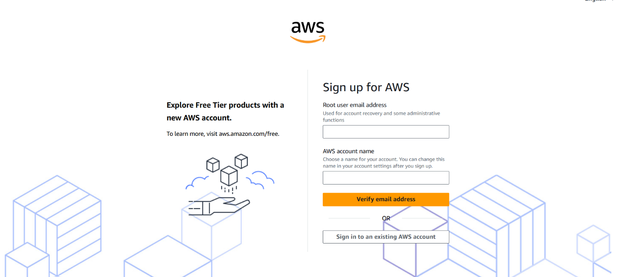
Step 2: Set Root User Password
- Create and confirm a password for the Root User.
- Click “Continue (Step 1 of 5)” to proceed.
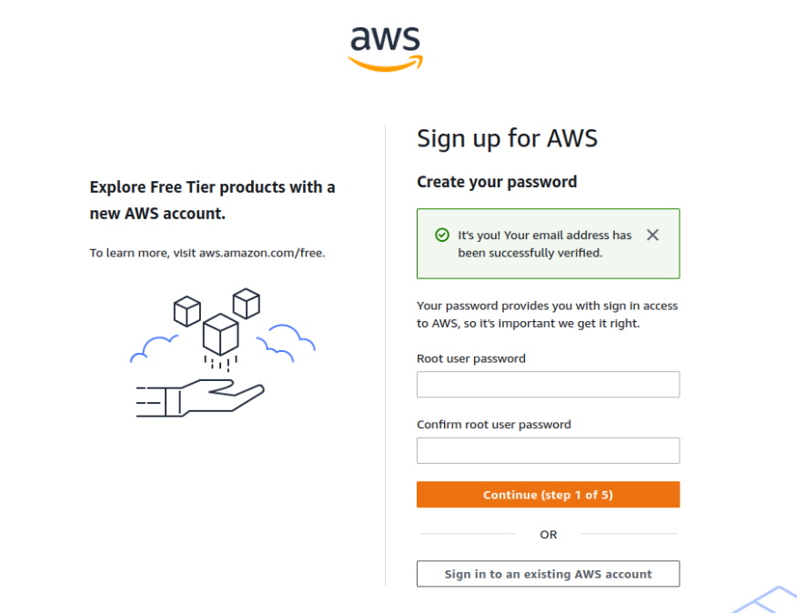
Step 3: Account Type Selection
- Select “Personal – for your own projects” as the account type.
- Fill in personal details, including full name, contact number, country, and address.
- Click “Continue (Step 2 of 5)” to proceed.
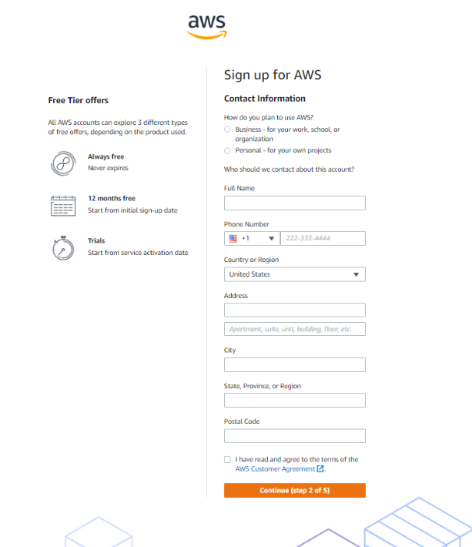
Step 4: Billing Information
- Provide valid billing details.
- Click “Verify and Continue” to complete the payment verification process.
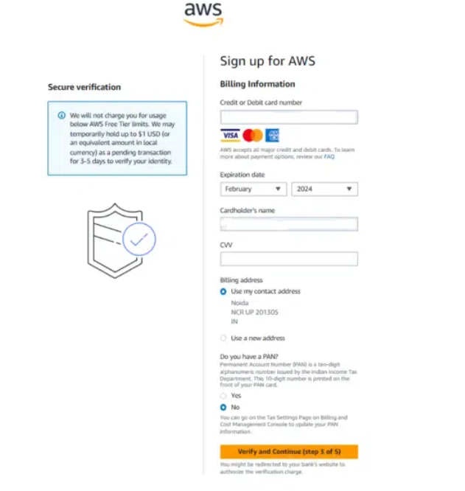
Step 5: Identity Verification
- Verify your identity using your mobile number or email.
- Enter the verification code received and click “Continue”.
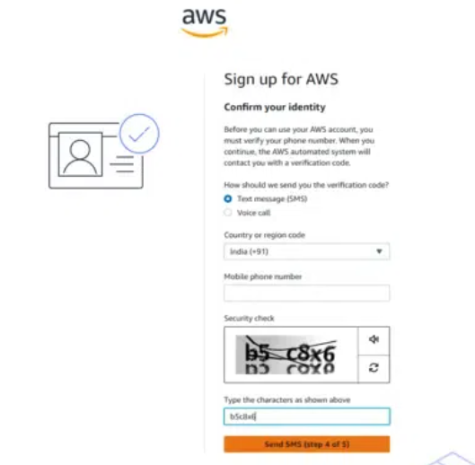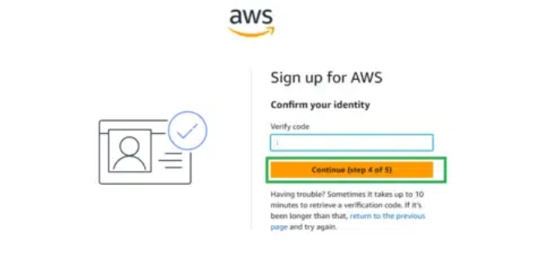
Step 6: Select Support Plan
- Choose “Basic Support – Free” as your support plan.
- Click “Continue” to proceed.
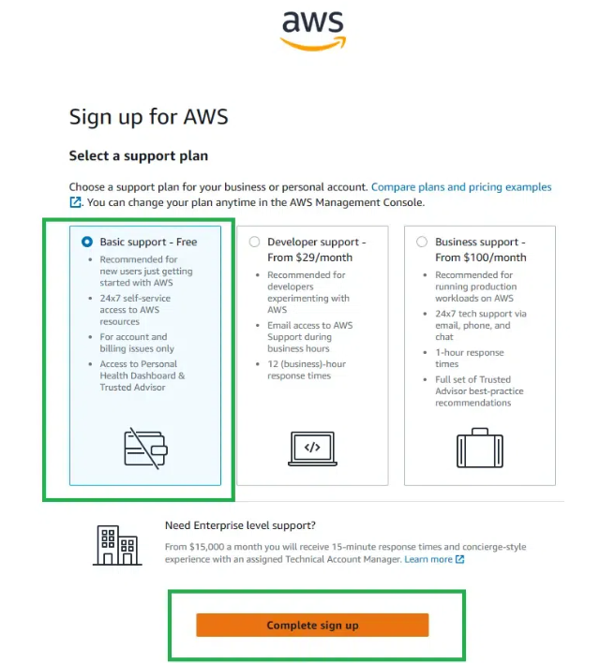
Step 7: Account Confirmation
- Your AWS account is successfully created and ready to use.
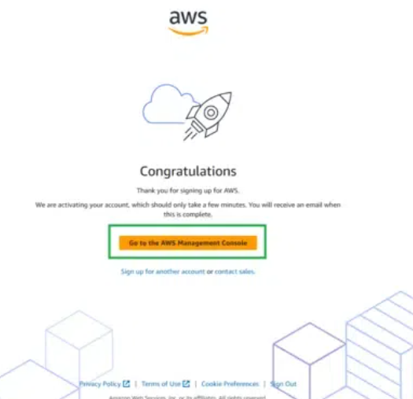
LANDING PAGE:
